HTWOL Utilization Manual

# 1. Introduction and General Overview

HTWOL is a tool designed to calculate the Life Cycle Assessment (LCA) of the water electrolysis supply chain. Its core strength is flexibility and granularity: you can obtain first results quickly by selecting ten 'one‑click' scenario elements, or you can fine‑tune more than fifty key parameters and methodological choices. The tool is intended for LCA practitioners, hydrogen industrial partners, environmental analysts, and the broader public interested in the environmental performance of hydrogen technologies.

In the tool, a reference scenario is defined when the user assigns values to all input parameters and selects providers. This can be done in a few clicks by choosing: the application (functional unit and associated H2 requirement), the background configuration (ecoinvent version and LCIA method), and pre-set configurations for the technical systems and energy mixes. Alternatively, the user may overwrite any default and enter custom values for input parameters and providers across the framework. Results automatically generated include contribution analyses of the reference scenario; comparison of different configurations of water electrolysis supply chain; and comparison with alternative technologies offering equivalent functions.

Two versions of the tool coexist:

The Demonstration Version. This version consists in evaluating the carbon footprint of all cradle-to-gate processes from literature. This version is open access and available online.

The Full Version. This version consists in evaluating the environmental impacts of water electrolysis with Impact World + indicators. This version relies on the ecoinvent database for calculating the impacts. An ecoinvent license is required for using this version of the tool. Please send an e-mail to [Gabriel.magnaval@hevs.ch](mailto:Gabriel.magnaval@hevs.ch) with a proof of your ecoinvent license for getting access to the full version.

The tool is based on the LCA framework of the paper “**Harmonizing the assessment of (Green) Hydrogen Supply Chain: a modular and parametrized Life Cycle Assessment Framework**” (under review). All datasets and equations are open-access, and available following this link:

You are kindly asked to cite the following when using the results of the tool:

We warmly thank our partners: the labs CIRAIG, HES‑SO, and the hydrogen partners Presshyous, Sustaincell, and Anemel, for their valuable contributions.

For any other questions or feedbacks, please contact the developers at gabriel.magnaval@hevs .ch.

# 2 User Guide

# 2.1 Getting Started

URL: https://h2tool.streamlit.app/

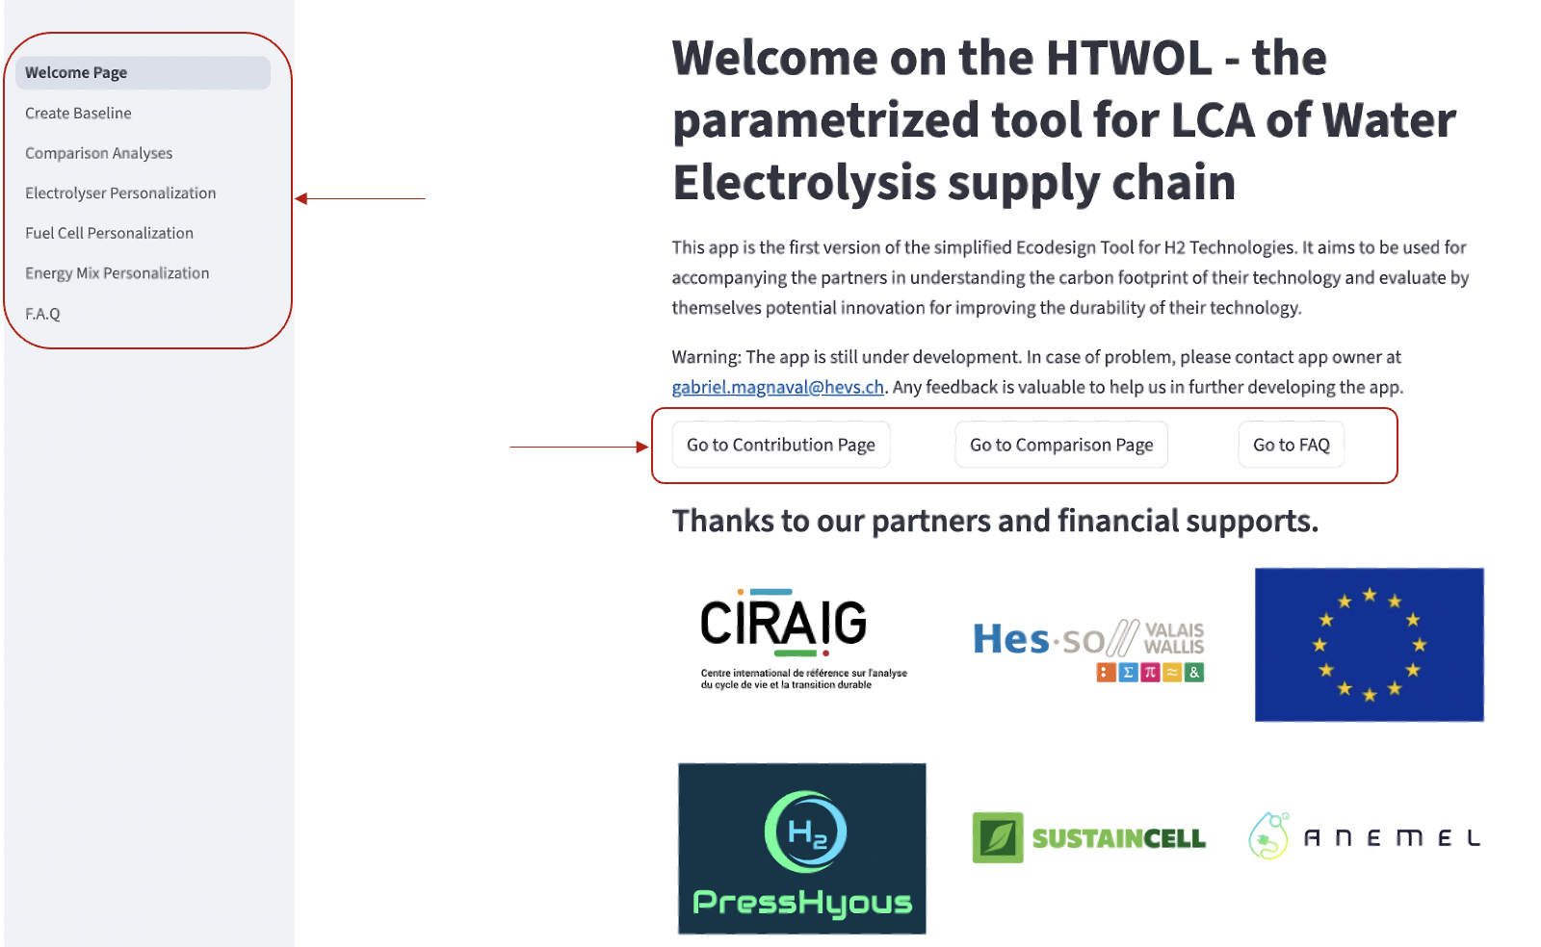First steps: six pages can be reached from the left sidebar or by clicking the buttons on the Welcome page.

• **Create Baseline** → For modeling baselines from ready‑to‑use configurations.  
• **Comparison Page** → compare two personalized baselines or alternative technologies.  
• **Electrolyser Personalization** → adjust parameters for the stack, BoP, and performance of an electrolyser.  
• **Fuel Cell Personalization** → adjust parameters for the stack, BoP, and performance of fuel cells.  
• **Energy Mix Personalization** → customize electricity and heat mixes.  
• **FAQ** → Frequently Asked Questions.

In the latter paragraphs, each section describes the use of one of these windows. **Words** in bold letters and underligned are defined in the glossary.

# 2.2. Create Baseline

For your first visit, click on create new scenario.

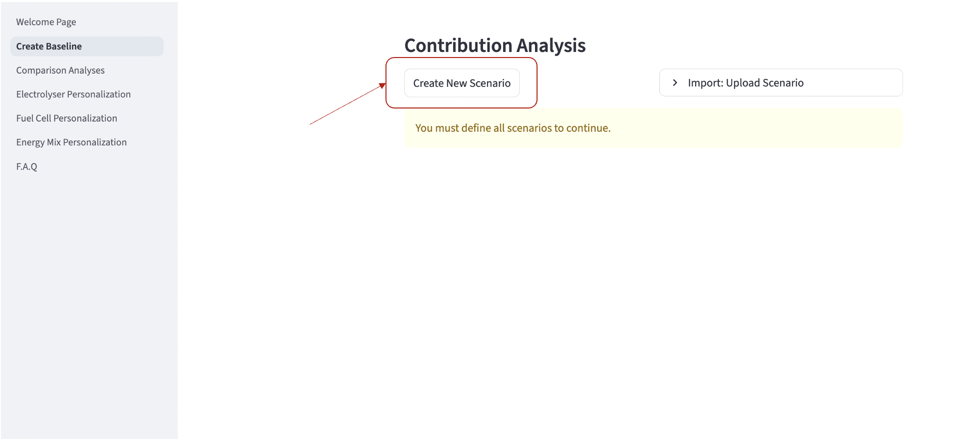

Define the scope of your study: select a **functional unit** (among the six main applications of hydrogen, see the methodology or the paper for further information); select a **LCIA method**.

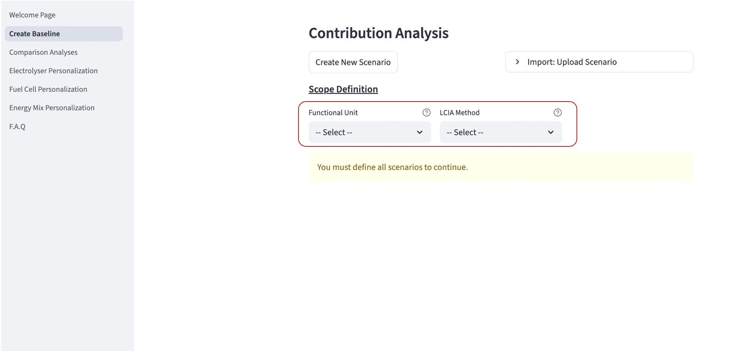

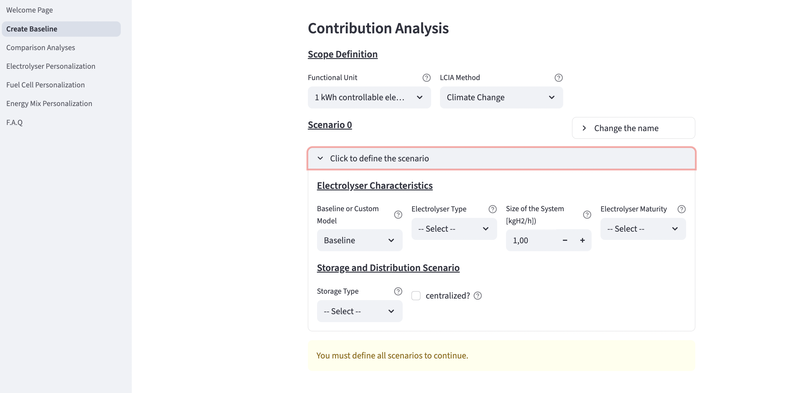Click on the section ‘click to define the scenario’ and select a pre-set configuration for all the elements. The list of elements to define depends on the functional unit selected. The Table 1 belows list the …

Definitions of terms are provided in the Glossary. The modeling is described in Section 4 and in the associated paper. The mention “you must define all scenarios to continue” remains while all required elements are not filled.

|  |  |  |  |
| --- | --- | --- | --- |
| Element/Box | Options / Type | Applicability | Comments |
| Change the name | Free text | Always |  |
| **Functional Unit** | 1kg H2, 1MJ heat, 1 stack, 1MJ domestic energy, 1 v.km, 1 kWh stored electricity, 1 kWh controllable electricity | Always |  |
| **LCIA method** | Climate Change, IW+ Footprint, IW+ Expert | Always |  |
| **Pressure Required [bar]** | Number | Only for 1kgH2 and 1MJ heat functional units |  |
| **Purity Required** | (**Grade A**, **Grade D**, **UltraPure**) |  |
| Electrolyser config | Baseline, Personalized | Always | Select Baseline to access pre-set configurations developed by our team.  Select Personalized to access your personalized modeling of electrolysers. |
| Electrolyser type | **SOEL**, **AEL**, **AEMEL**, **PEMEL** | Always |  |
| **Size** of the system [kgH2/h] | Number | Always |  |
| **Electrolyser maturity** | **Commercialized****,** **SoA****,** **Target 2050** | Always |  |
| **Storage** type | None, Buffer Tank (Daily), Buffer Tank (Weekly), Geological Storage (Season) | Always |  |
| **Centralized?** | True (check), False (not check) | Always | Check if your system is centralized (production and use not at the same location) |
| **Distribution Type** | **None, Pipeline (250km), Pipeline (2500km)** | Only if centralized |  |
| **Storage/Distrib maturity** | **Commercialized****,** **SoA****,** **Target 2050** | Only if storage or distribution is not None. |  |
| Fuel Cell config | Baseline or Personalized | Only when hydrogen reconversion is required. (1 MJ co-generation; 1 kWh stored; 1 kWh controllable elec.; 1v.km transportation) | Select Baseline to access pre-set configurations developed by our team.  Select Personalized to access your personalized modeling of electrolysers. |
| **Fuel** **Cell type** | **SOFC****,** **AFC****,** **AEMFC****,** **PEMFC** |
| **Fuel** **Cell size [kW]** | Number |
| Fuel Cell **maturity** | **Commercialized****,** **SoA****,** **Target 2050** |
| **Electricity** **mix** | **Renewable**, **Nuclear**, **Grid** | Always |  |
| **Heat mix** | **100% elec****,** **100% heat****,** **available heat** | Only for SOEL |  |
| **Heat recovery** | True, False | Only for  fuel cells. | Select the check to model heat recovery (exergy allocation) |

Once all boxes are filled, the results (graph + table with raw results) are automatically calculated and available above the scenario definition boxes.

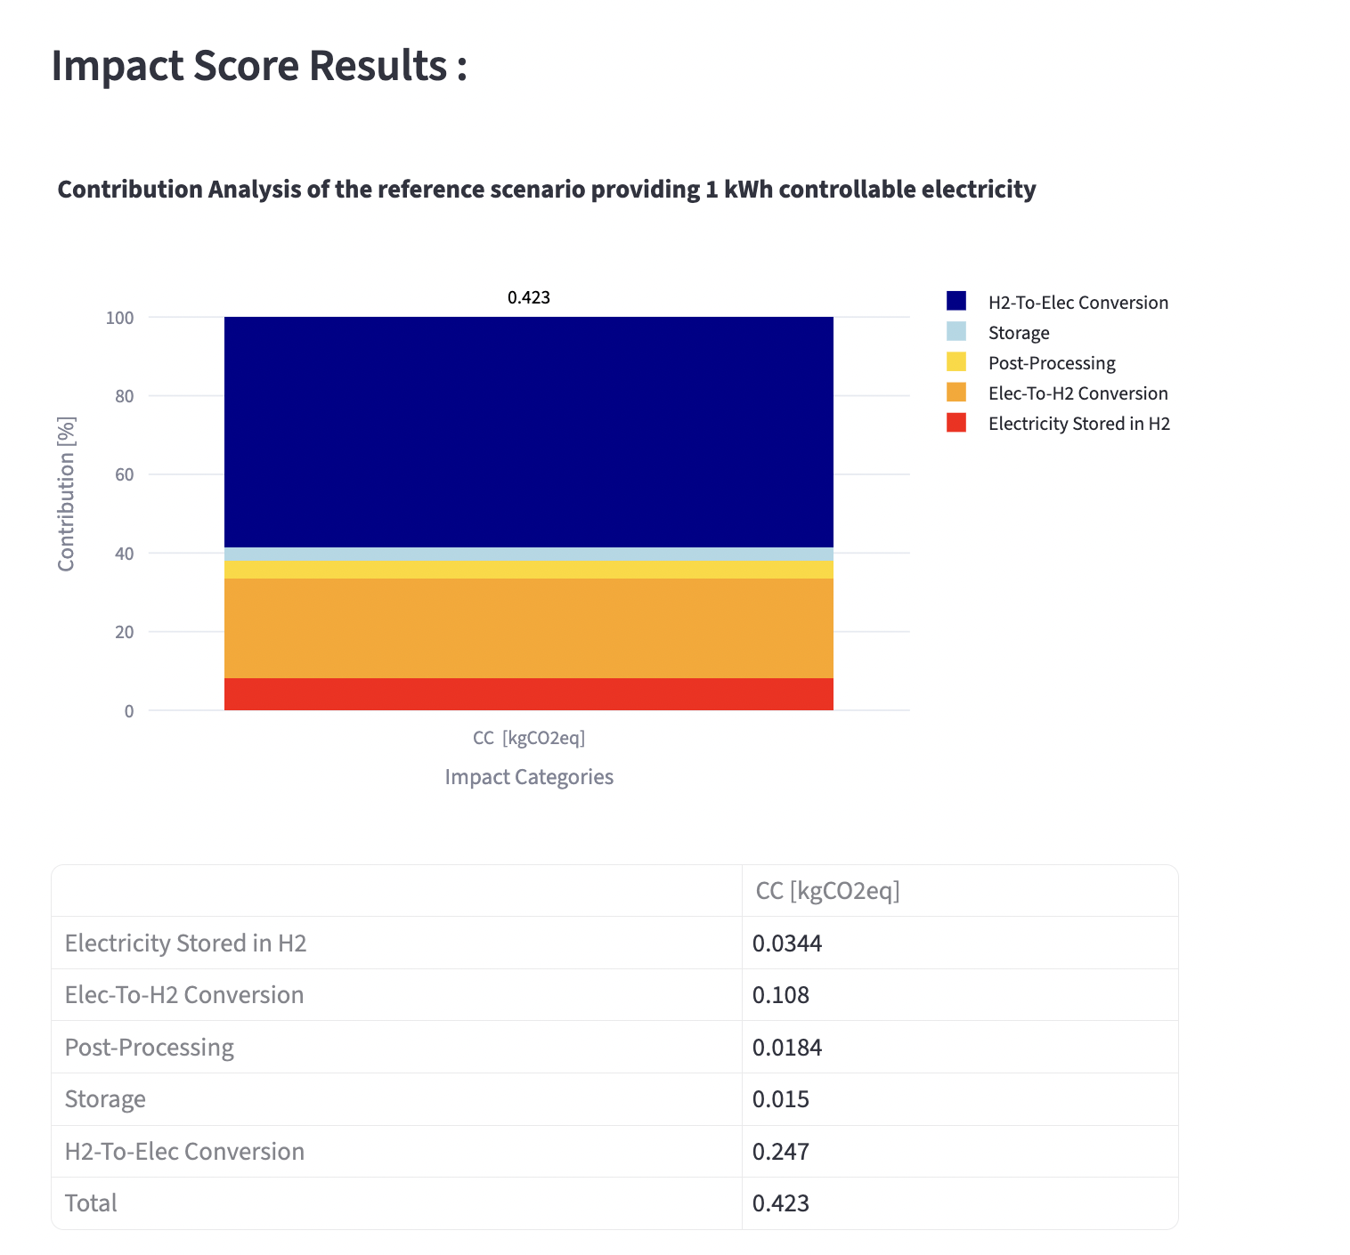

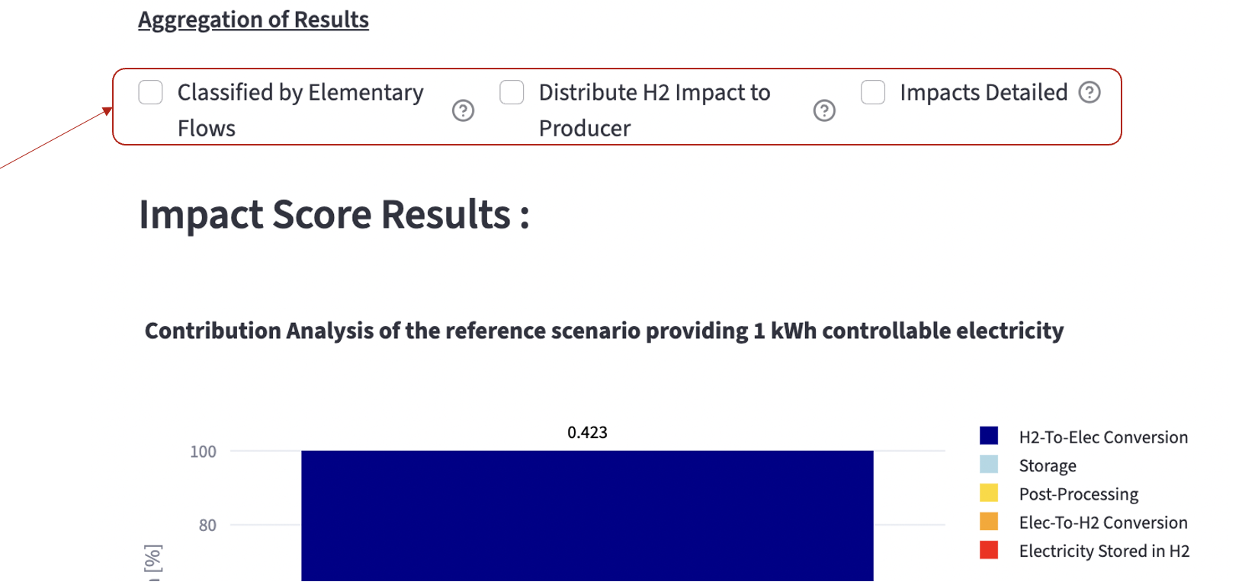Results can be organized differently using the check in the section “aggregation of results”.

|  |  |
| --- | --- |
| **Default:** (a) results organized per main life cycle stages. (b)impacts of surplus of H2 is allocated to the processes where H2 losses occur.  (c) few level of details. |  |
| **(a) by clicking on “Classified by elementary flows” ->** results are aggregated per elementary flows (electricity, heat, stack manufacturing, ect) |  |
| **(b) by clicking on “Distribute H2 impacts to producer” ->** impacts due to surplus of H2 to produce are allocated to all the upstream processes that are required for producing this surplus (see section X for more details) |  |
| **(c) by clicking on “Impacts detailed” ->** impacts are more desegregated. |  |

Users can also import an existing scenario or export results/scenarios as CSV.

# 2.3. Comparison Analysis

Users can compare a reference scenario with another scenario or an alternative technology.

## 2.3.1 Comparison with Another Personalized Scenario

Keep the cursor “Please Select the type of comparison you want to assess” on the left to compare two FC&EL systems (see image below). The first scenario you modeled in the ‘Create Baseline section is already saved in the memory.

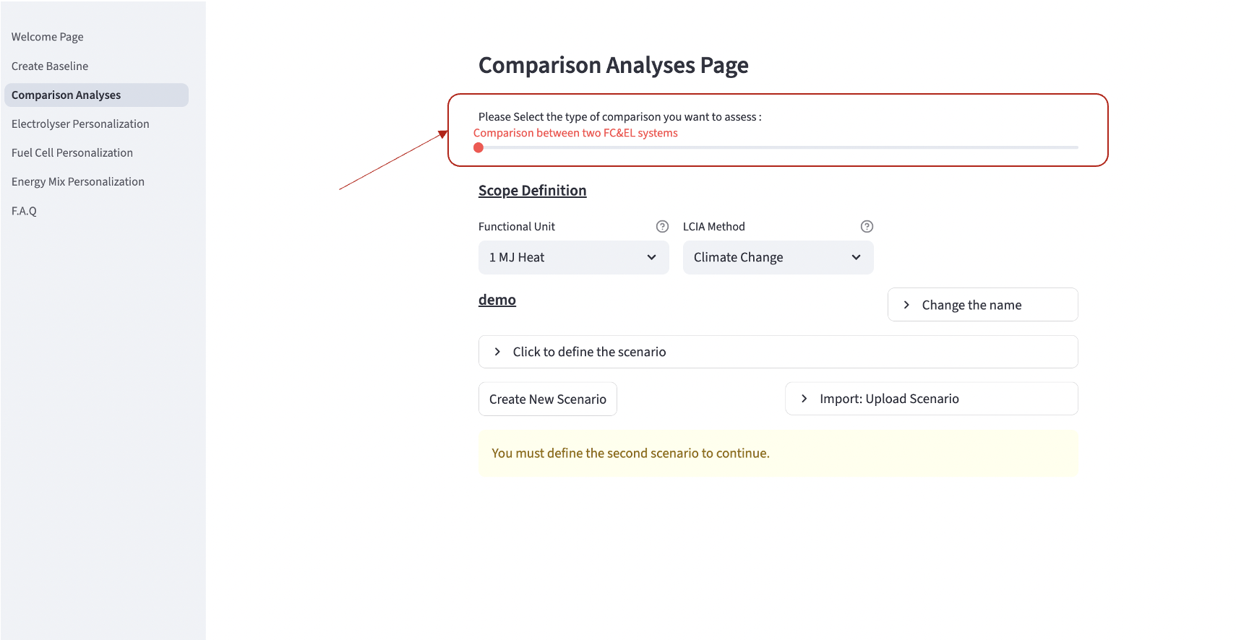

The second scenario is defined with the same requirements as in Section 3a (except the Functional Unit and the LCIA method that are kept the same for ensuring consistent comparison). Once the second scenario is defined, result graphs and tables are automatically plotted. Results can be aggregated following the same options as for the single contribution analysis.

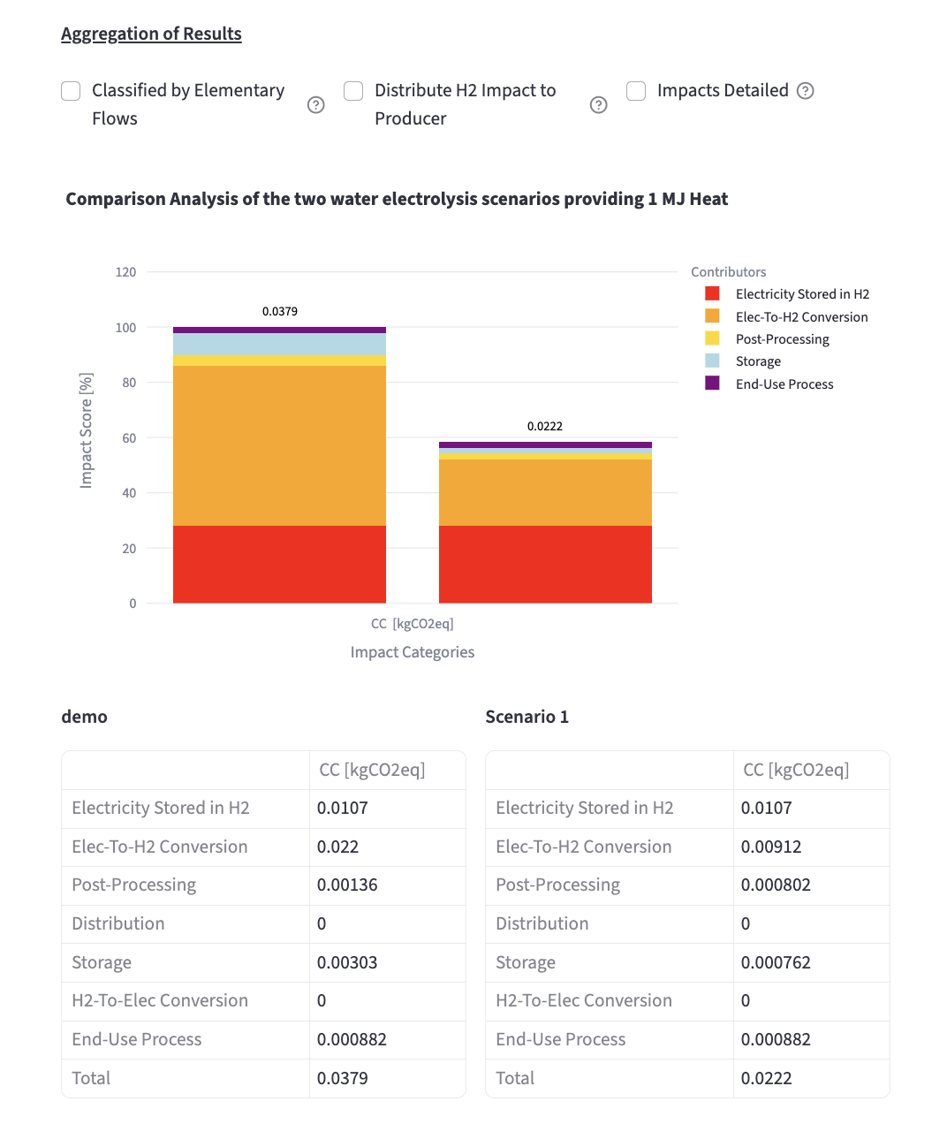

## 2.3.2 Comparison with Alternative Technologies

The baseline scenario created in ‘Create Baseline’ can also be compared with alternative technologies delivering equivalent service. The table XX sums up these alternative technologies depending on the functional unit selected.

|  |  |
| --- | --- |
| Functional Unit (FU) | Alternative Technologies |
| 1 kg H2 | Steam Methane Reforming |
| 1 MJ heat | Electricity, Fuel |
| 1 MJ cogeneration | Electricity+Heat Pump, Electricity+Fuel, Electricity+Natural Gas, Electricity+Wood |
| 1 v.km | BEV (powered by renewable electricity), BEV (powered by grid electricity), GV |
| 1 kWh stored | Hydro, Battery |
| 1 kWh controllable electricity | Nuclear, Combined Cycle |

To compare the baseline with an alternative technology, push the cursor “Please Select the type of comparison you want to assess” on the right.

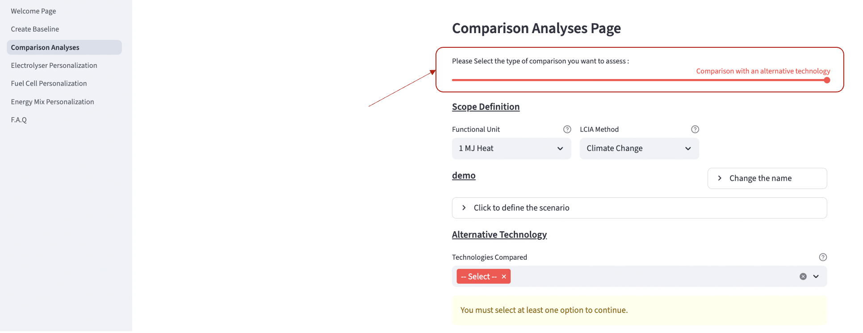

Select in the section ‘alternative technology’ the list of technologies you want to compare with the FC&EL baseline. The results (graph and table) are automatically plotted.

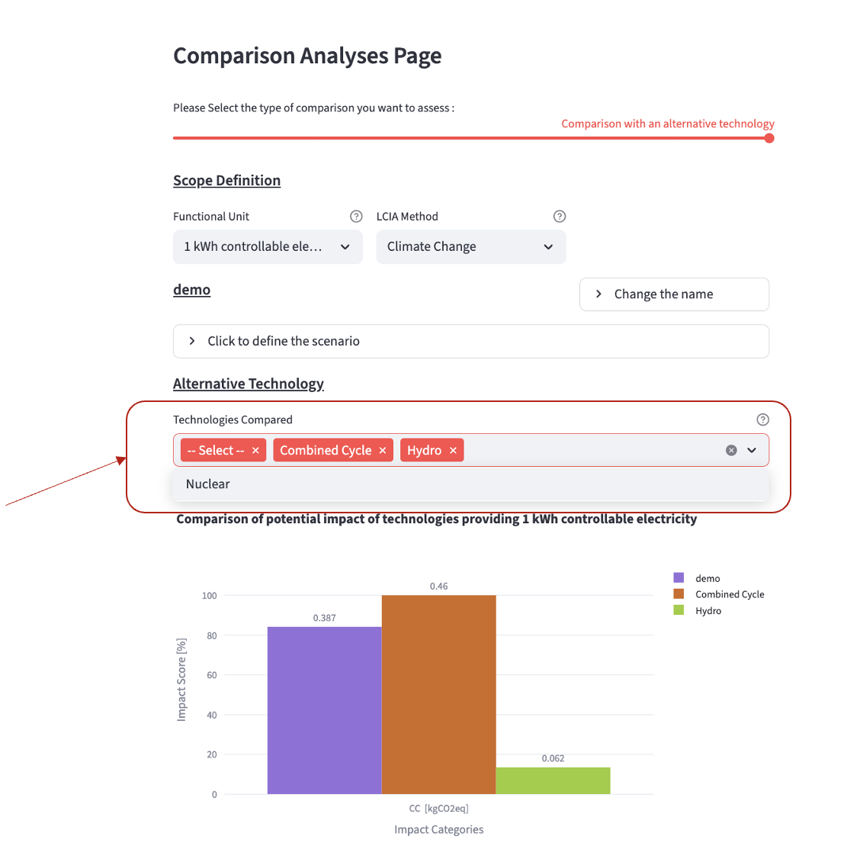

# 2.4 Electrolyser and Fuel Cell Personalization

Users can personalize electrolysers or fuel cells for use in scenarios.

First select an existing scenario to initialize parameters. This can be one of our baseline, or one electrolyser/fuel cell previously personalized by the user.

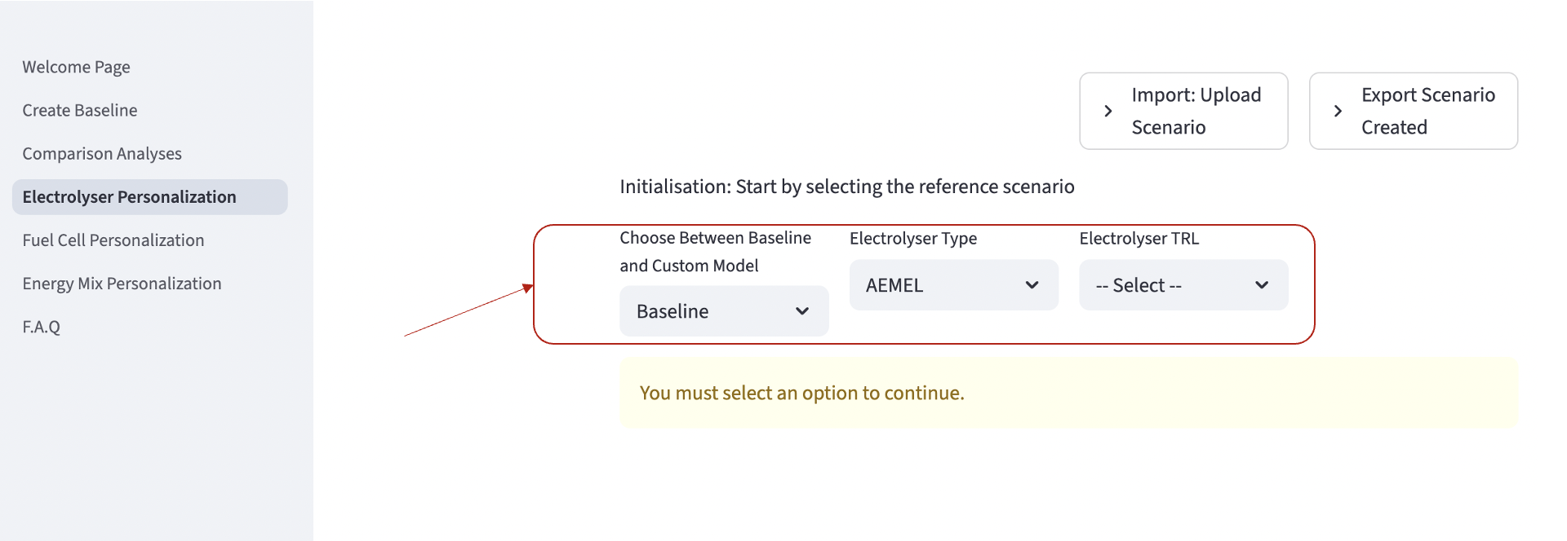

Once the initial scenario is confirmed, the following page automatically appears. All adjustable parameters of the model are classified in three sections: stack manufacturing, BoP equipment and operation of the system. You can move from one section to another by clicking on the categories below ‘please select a life cycle stage’.

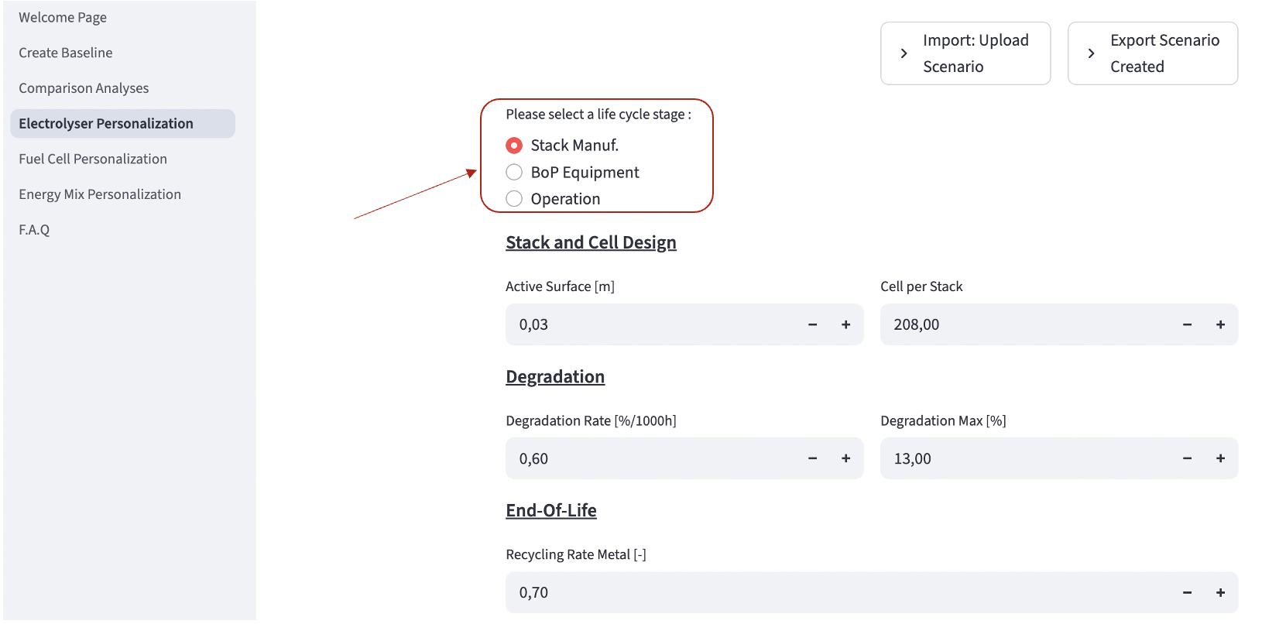

The following parameters can be personalized. The value initially printed depends on the initial scenario you selected. To adjust a parameter, simply click in the box and enter your personalized value.

|  |  |
| --- | --- |
| Category | Parameters |
| Stack Manufacturing Elements | |
| Design Parameters | **Active Surface****,** **Cell per Stack** |
| Degradation | **Degradation Rate****,** **Maximal Degradation** |
| End of Life (EoL) | **Recycling Rate** |
| Stack Layers | **Electrodes****,** **Membrane****,** **Bipolar plate****,** **End plate** **: thickness, ratio, material, additive** |
| **Additive** | Material, Quantity or Thickness |
| Stack Structure | **Frame****,** **Collector****,** **Sealant** – Material, Quantity |
| Balance of Plant (BoP) | |
| BoP General | **Lifetime** |
| BoP Elements | **Compressor****,** **HEX****,** **Chiller****,** **Rectifier****,** **Separator****,** **Pump****,** **Piping****,** **Instrumentation****,** **Tank****,** **Container** **: Size** |
| Operation Parameters | |
| Operation parameters | **BoL voltage, current density, water demand, KOH demand, H2 leakage rate, heat demand (EL only), heat recoverable (FC only), fuel utilization (FC only)** |

Once parameters are adjusted, the work SHOULD be saved. Click on 'Create a new scenario' at the bottom of the page.

Enter the name of the scenario and click on the button to save the work. A new scenario is created.

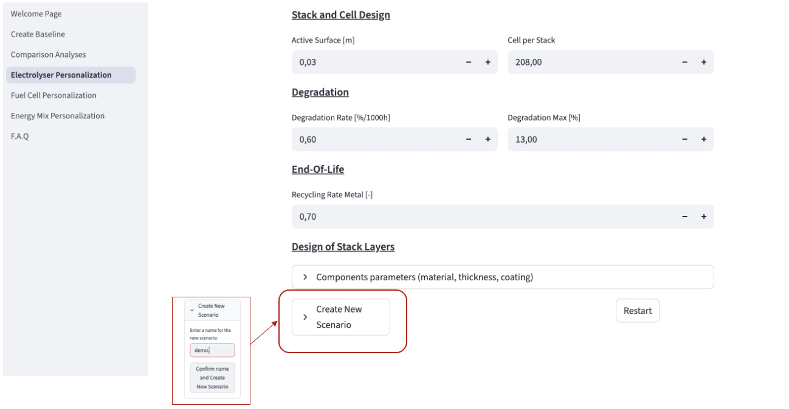

If the work was initialized with a Personalized scenario (already created by the user, in our case the one called ‘Demo’), the work can either be saved by creating a new scenario (e.g., Demo-v2), or by saving the new values of the parameters in the same scenario, replacing the previous values of this scenario. For this second option, click on the button ‘Save

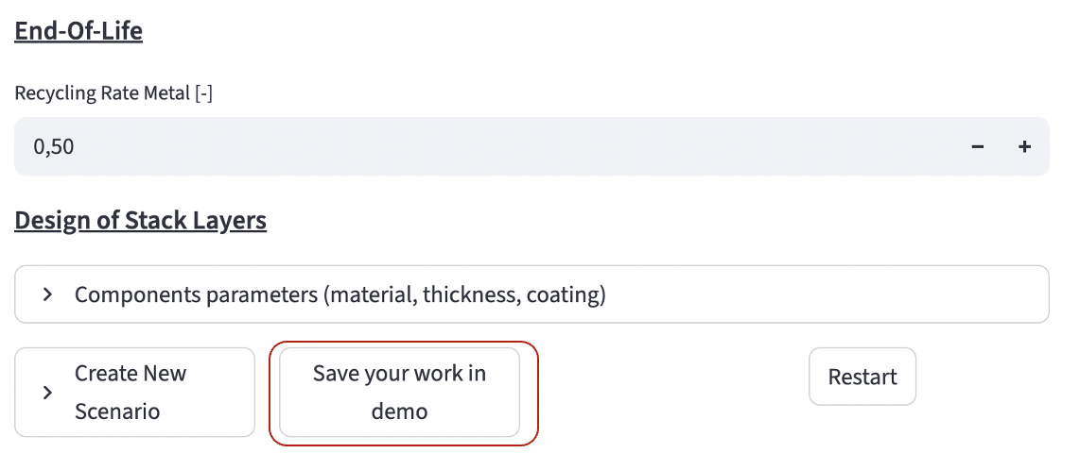

To cancel the work and restart from scratch (i.e. defining the initial scenario, click on the button restart at the bottom of the page).

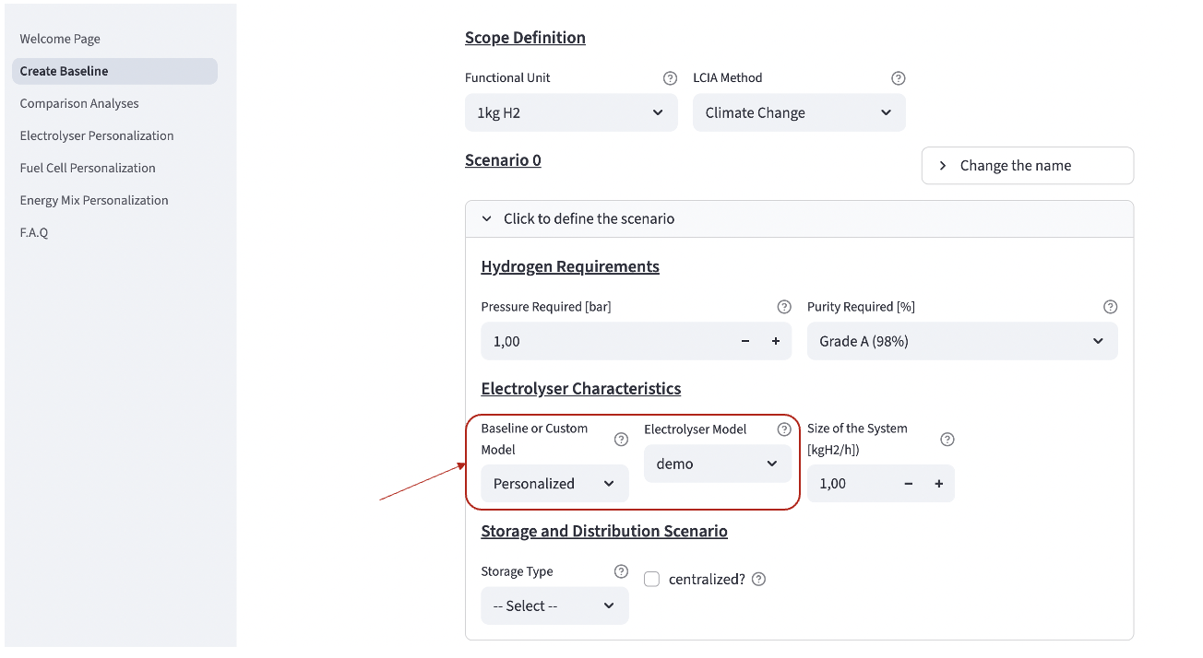The personalized electrolyser and fuel cell models can be used directly in the calculation tool. When creating a new baseline, you can simply select Personalized in the category ‘Baseline or Custom Model’, and select the name of your model.

Baseline scenarios are locked and cannot be overwritten. Personalized scenarios can then be reused in Reference Scenario or Comparison Analysis pages.

Personalized scenarios can be exported and downloaded for later reuse or sharing with the community. Click the top‑right button 'Export Scenario Created' after renaming the file in the dedicated box. A .csv containing all scenarios created—including scenario names and parameter values—is downloaded directly to the user's computer. To import these elements later, click on 'Import' (details to be updated).

# 2.5 Energy Mixes

Users can personalize energy mixes.

First select if you want to personalize electricity or heat mix.

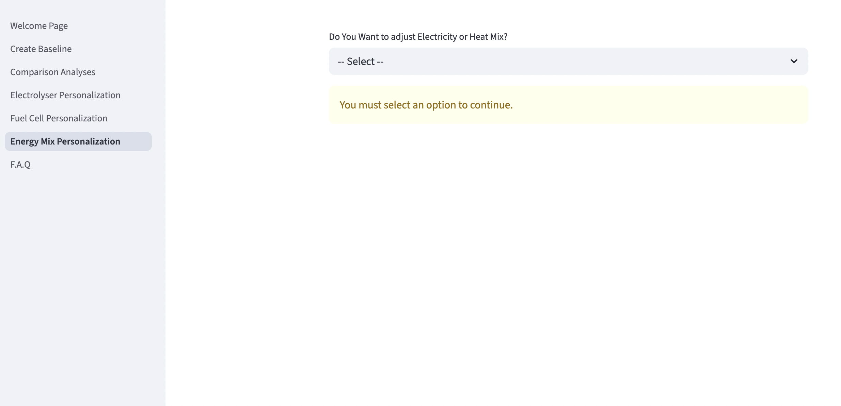

Second, enter the ratio of each of the mean of production available. The sum of all shares must reach 1.

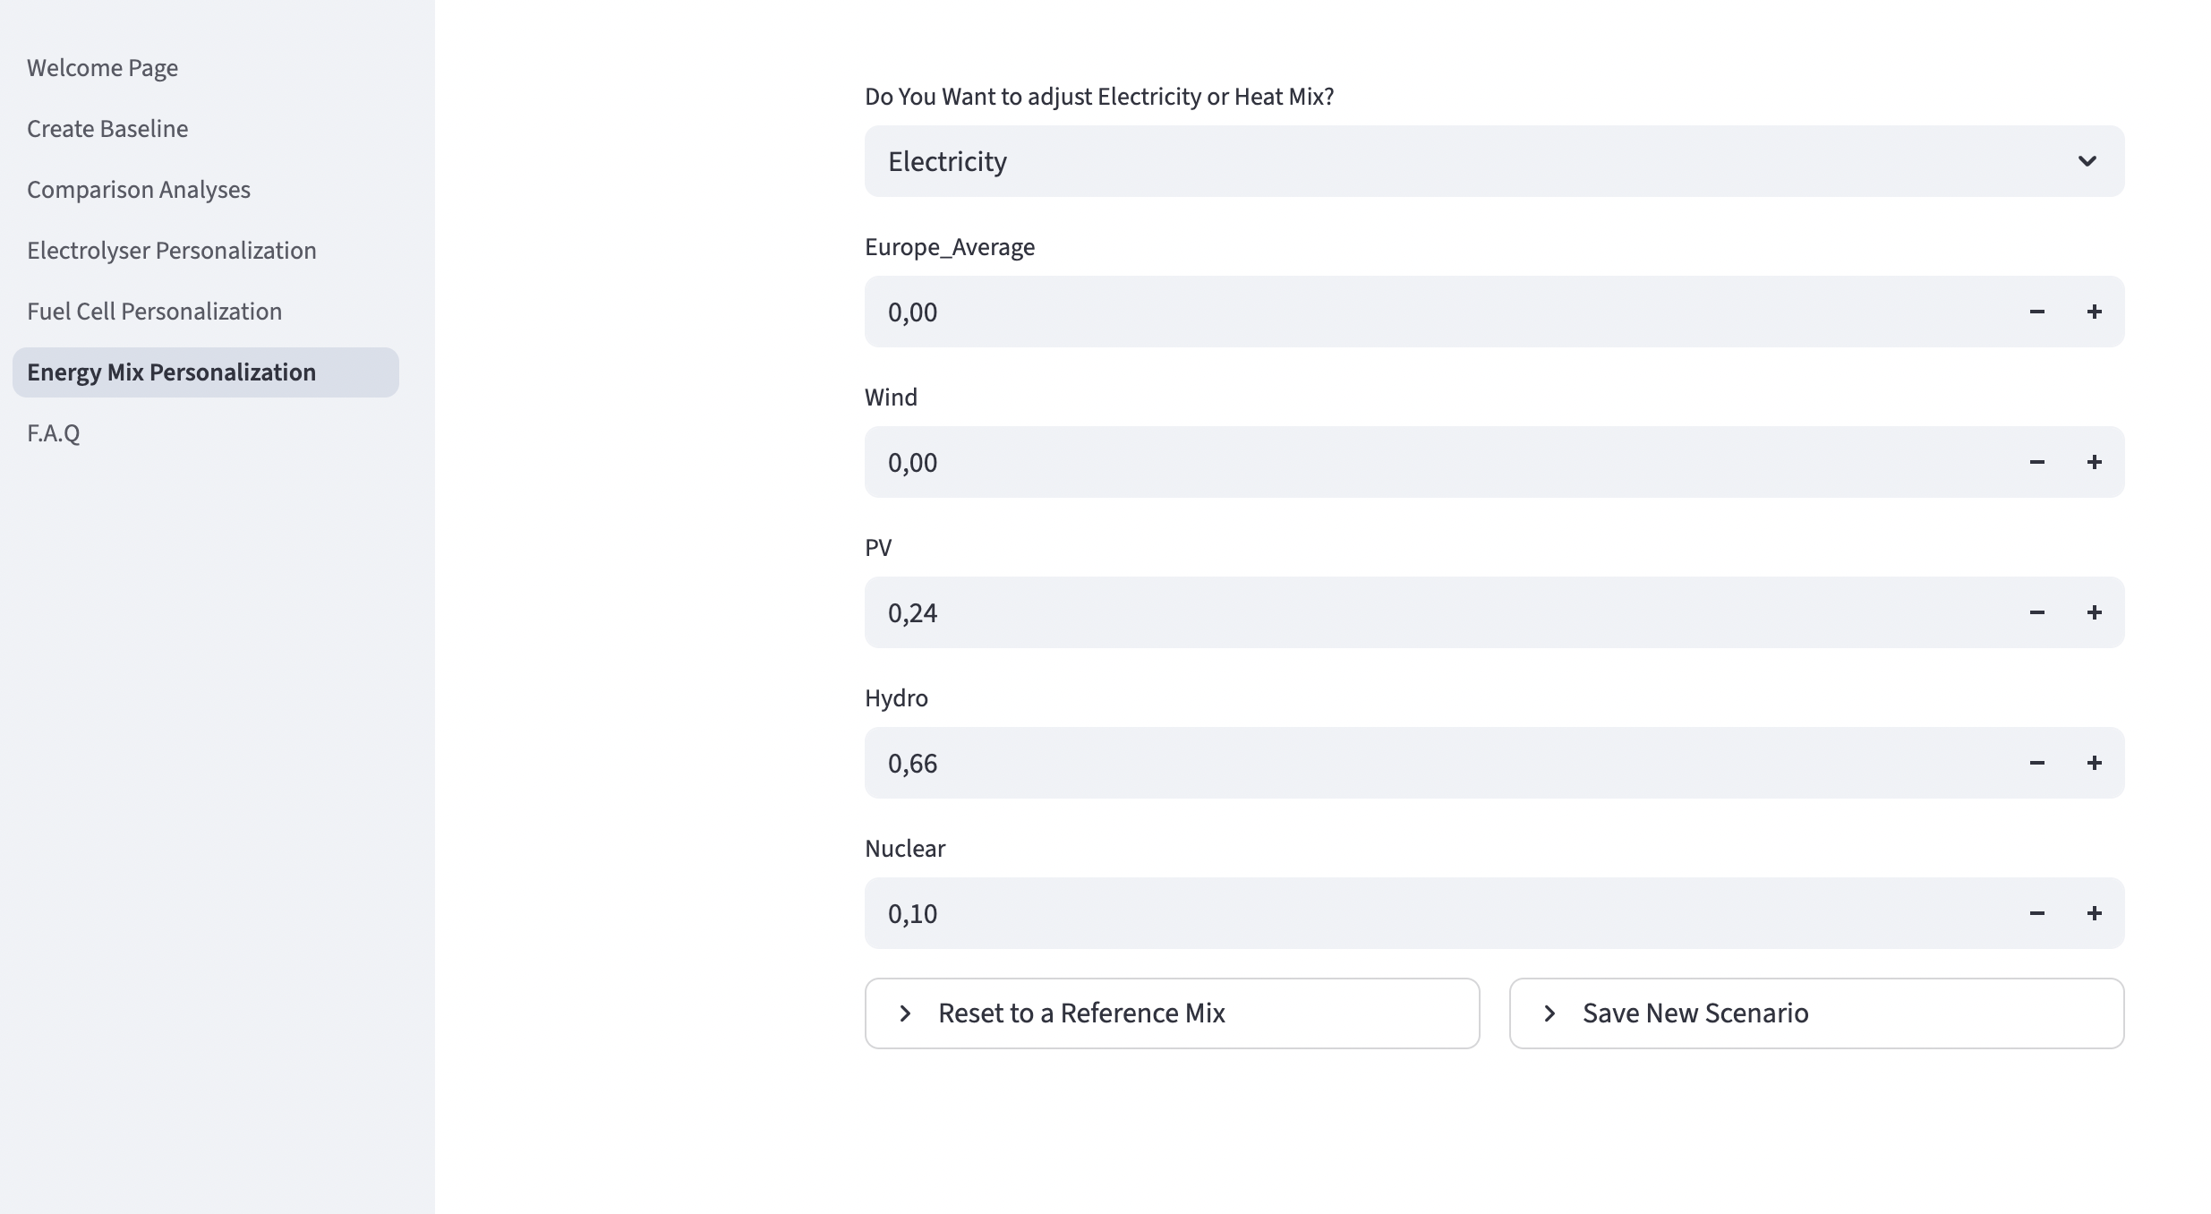

Save your scenario as for EL and FC, by clicking on “Save New Scenario”, entering the name and confirming by clicking on the button.

For reset, or for initializing based on existing electricity and heat mixes developed as a baseline for the tool, click on the left on “reset to a reference mix” and select the baseline you want. The share of each mean of production is quantified based on these baselines.

The new energy mixes can be selected when creating a baseline in the energy scenario definition.

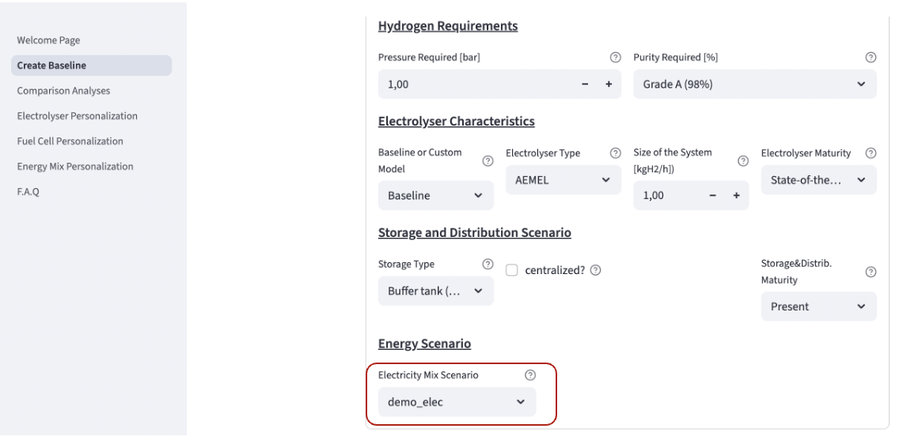

# 2.6 Export and Import Work

We encourage users to export their work for two reasons: (1) this is the only way to save the work from a session to another. When quitting the page, all work that has not been exported is lost; (2) we encourage HTWOL users to use the .csv exported as supplementary information is their reporting, so that the community can build on the personalized model and baseline created. Exportation should be done in two steps: first, exportation of the personalized model of fuel cell and electrolyser; second, exportation of the baseline created.

# 2.6.1 Export and Import Electrolyser and Fuel Cell personalized model

For exporting the FC&EL model created, please reach electrolyser personalization and fuel cell personalization windows. Click on top right on the button called ‘export scenario created’. Change the files name, and click on download personalized models. A .csv file is downloaded directly on your computer.

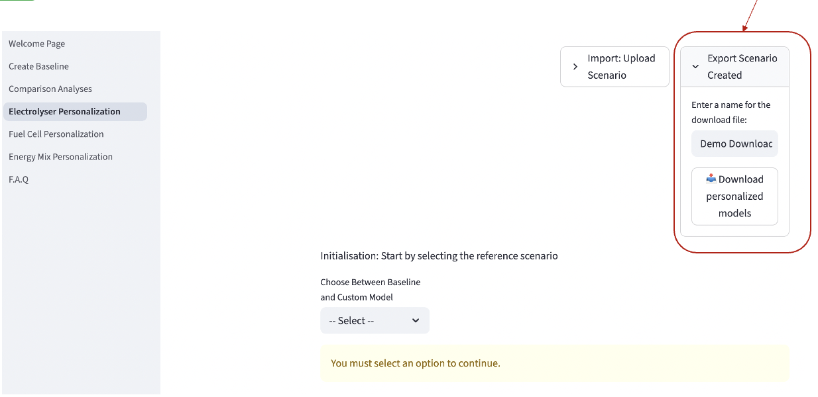

This file can be import later on the website, so that all your saved model can be reimported and reuse from where you were. For this, click on ‘Import: upload scenario’, and browse your personal file to find the .csv you want to import.

**Important information: you can only import .csv that were generated previously by the HTWOL. Do not attempt to import another file you created.**

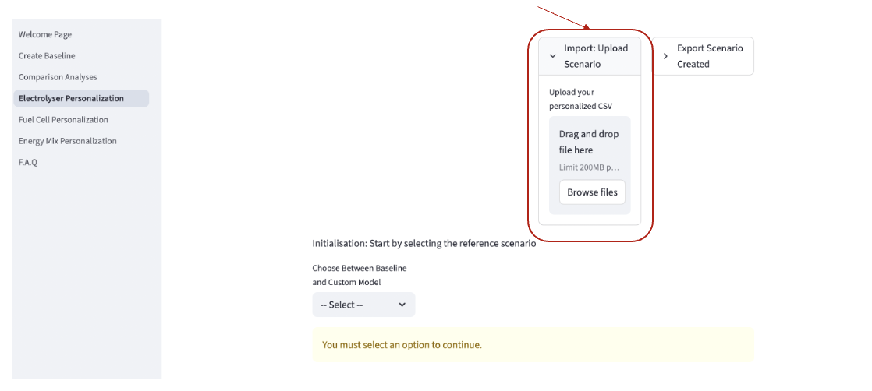

# 2.6.2 Export and Import Baselines

After having generating results in the ‘Create baseline’ page, reach the end of the page. You will find the ‘export scenario created’ button. Click on this button, change the name of the file, and confirm. A .csv containing all the pre-set configurations selected will be downloaded directly on your computer.

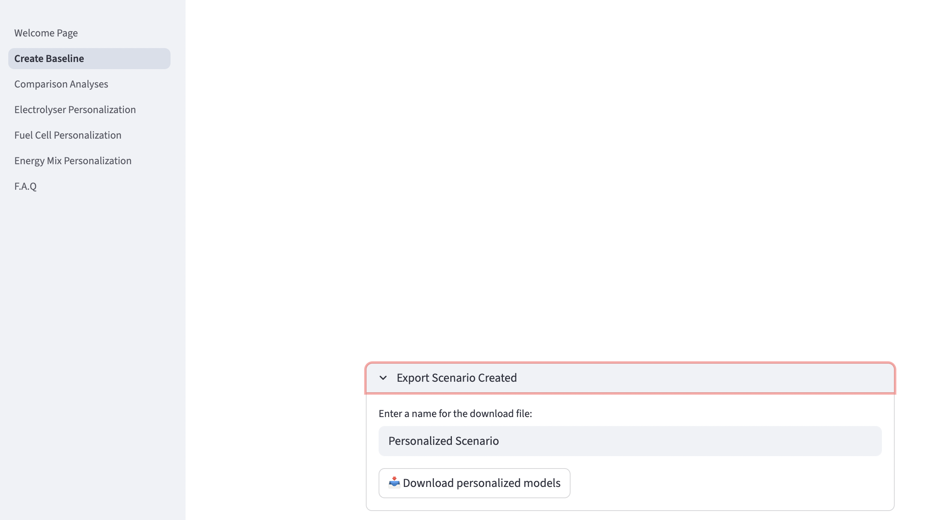

This work can be imported later, when creating a new baseline. Instead of selecting “create new scenario” when creating a baseline, click on the ‘Import button’ on the right. Browse your files, and select the baseline you want to reuse.

**Important information: you can only import .csv that were generated previously by the HTWOL. Do not attempt to import another file you created.**

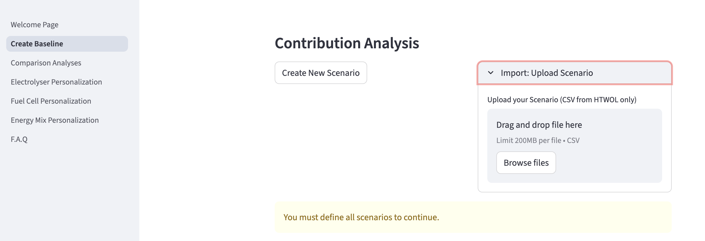

# 3 Overview of the methodology

## 3.1 – LCA Methodology

The system boundaries of the system is represented in Figure 1. It includes six main life cycle stages: the production of electricity, the conversion of this electricity into hydrogen using an electrolyser, the post processing of the hydrogen to reach technical requirements (such as pressure and purity required by the hydrogen application), the distribution of the hydrogen from production site to application site, the storage of the hydrogen, and the reconversion of hydrogen into electricity using a fuel cell. The hydrogen supply chain is linked to hydrogen main applications by end-use functional units. This ensures that the system boundaries include all processes required for assessing the FC&EL technologies to their final service or product they provide. The color code used in the figure is the same than the one used in the graphs, in the HTWOL.

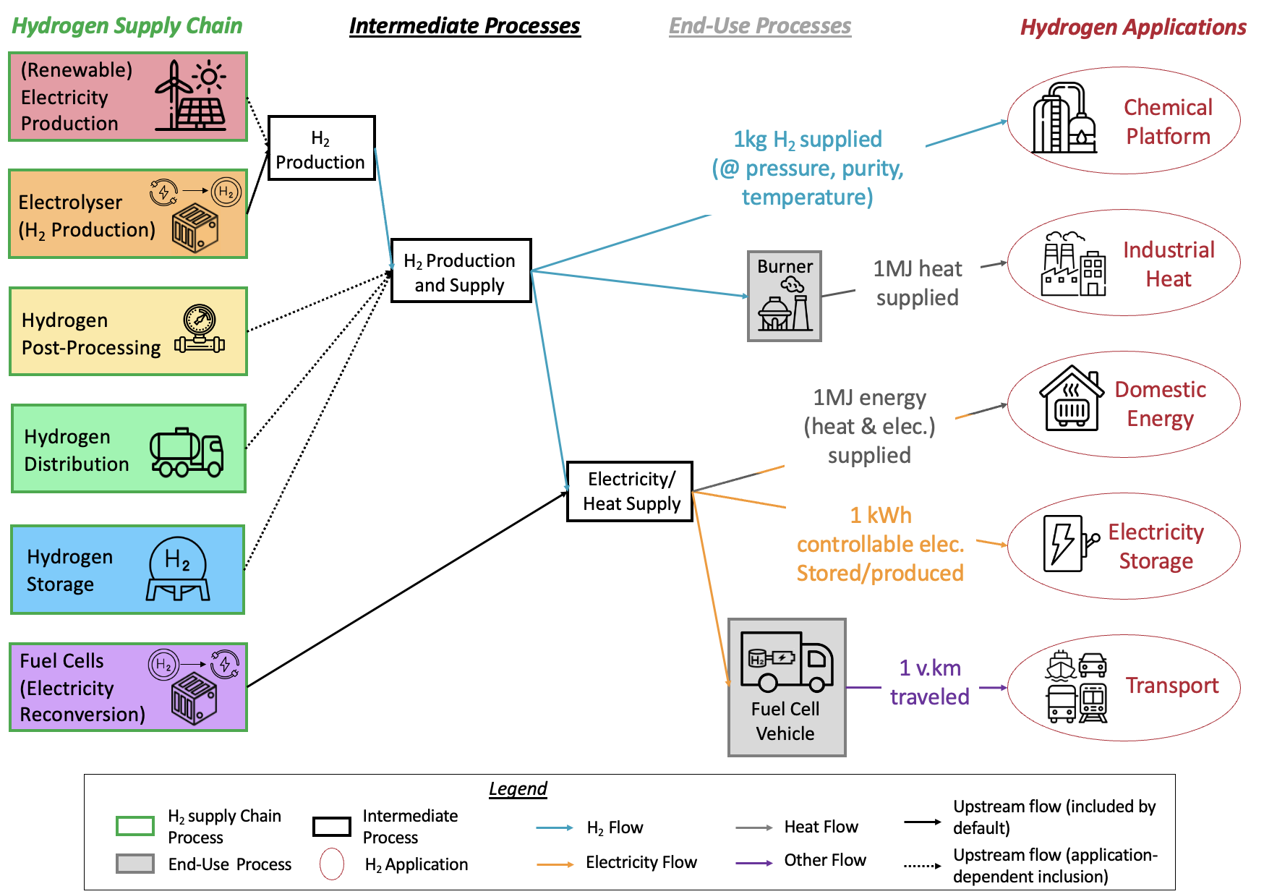

Figure 1. Graphical representation of the green hydrogen product system with explicit links with hydrogen applications.

Each of the main life cycle stage is further described in Figure 2 by a modular structure. The elementary processes in all the modules are classified into four categories: the operation consumables (in pink), the stack manufacturing (in grey), the equipment manufacturing (in brown) and the end-of-life of the system (in khaki). The same colors are used for contribution analysis, with the results aggregated by elementary flow in the HTWOL. Further details on the methodology are available in the paper and its supplementary 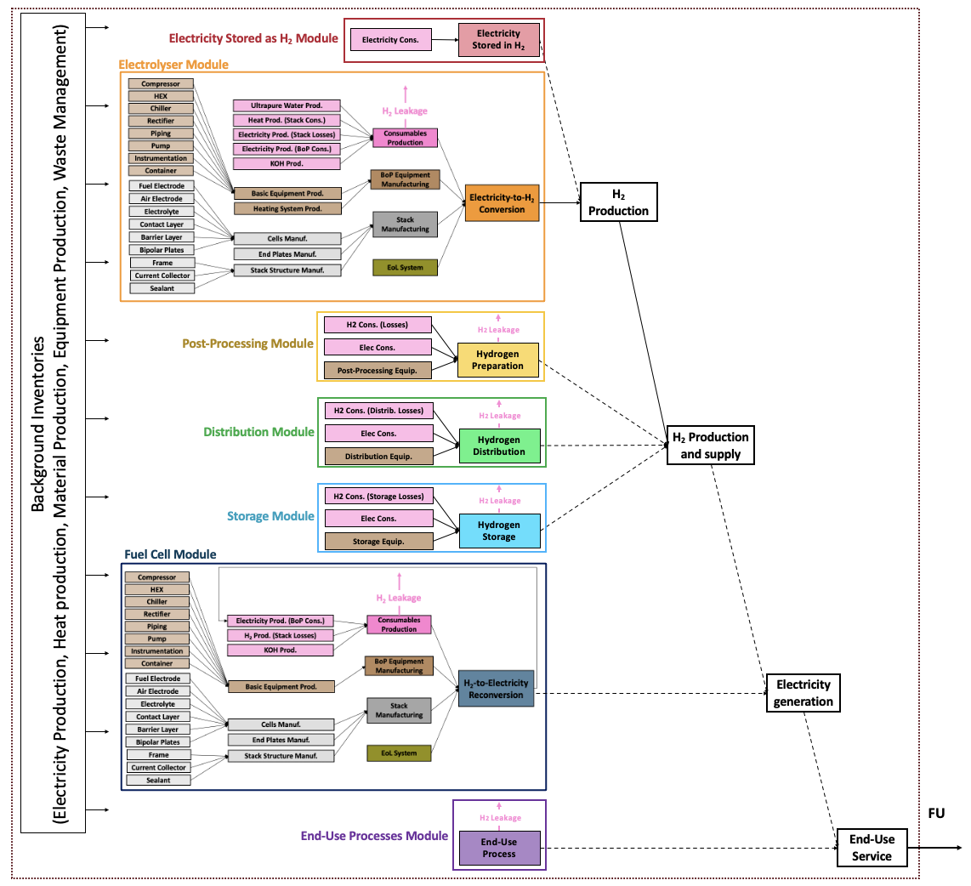information.

Figure 2. Modular structure of the green hydrogen product system**.** The system is organized into modules—coherent groups of one or more elementary processes that delivers a specific intermediary flow throughout the hydrogen life–cycle.

## 3.2 – Tool Architecture

### System overview

The tool is organized around a single computation engine, **model_H2**, which receives three inputs: (i) the functional unit (FU), (ii) the life cycle impact assessment (LCIA) method, and (iii) a complete vector of inventory parameters. Given these inputs, model_H2 performs all calculations and returns environmental impact results. The complete organization is shown in Figure 3 and described in the following.

### User input and preset management (foreground)

User interaction occurs via a Streamlit interface that orchestrates input collection for the **foreground** system. Inputs can be provided in two modes: (1) selection of curated preset configurations, or (2) direct parameter personalization. Both modes are handled by **H2_preset**, which stores preset datasets, validates any user-specified values, and assembles a coherent parameter set. H2_preset also records the user’s FU, LCIA method, and preferred result-display options to ensure consistent downstream processing.

### Background data and inventory coupling

Cradle-to-gate (**background**) processes are supplied by **LCI datasets**, which provide process inventories and impact intensities required by the calculator. These datasets are not modified by the user; instead, they serve as stable references that are programmatically coupled to the foreground parameters assembled by H2_preset. The resulting combined inventory constitutes the full input to model_H2.

### Calculation engine

Given the FU, LCIA method, and complete parameter vector, **model_H2** executes the life-cycle calculations and produces environmental impact results.

### Visualization

Visualization is handled by **H2_plotting**, which reads the model outputs and renders figures according to user preferences registered in H2_preset. This design allows seamless switching between stage-level and flow-level representations or between different levels of details without reconfiguring inputs, facilitating exploratory analysis and result communication.

### Scenario export and reproducibility

Complete scenarios—including inputs (FU, LCIA method, foreground parameters, preset identifiers) and outputs (aggregated impacts)—can be exported. This is handled by **H2_export**. This simplifies usability, external review, and downstream comparison across scenarios.

Figure 3. HTWOL simplified architecture.

# 6. Glossary

**LCIA method: Life Cycle Impact Assessment method.**

**Climate Change**: LCIA category focused on GHG emissions.

**IW+ Footprint**: the Footprint version of IW+ assesses five categories of impacts: the Carbon footprint (in kgCO2eq.), the Water Scarcity footprint (in m3 world-eq), the Fossil and Nuclear Energy Use (in MJ deprived), the Remaining Human Health (in DALY) and the Remaining Ecosystem Quality (in PDF.m2.yr). The category indicators rest of human health and rest of ecosystem quality are presented excluding the contributions of climate change indicators and water availability indicators.

**IW+ Expert**: Expert version of IW+ aggregates damage results into two Areas of Protection: Human Health (expressed in DALY) and Ecosystem Quality (expressed in PDF.m2.yr), with midpoint indicators feeding into these endpoints.

**Pressure and Purity Required**

This concerns the pressure and purity required by the **end-use applications**. The specific requirements for the storage, the distribution or for the fuel cell are automatically taken into account in the background datasets.

**Grade A**: Purity grade A (i.e. 98% purity)

**Grade D**: Purity grade D (i.e. 99.97% purity).

**UltraPure**: Ultra-high purity hydrogen (i.e. 99.999% purity).

**FC&EL Technologies:**

**SOEL**: Solid Oxide Electrolyser (high-temperature).

**AEL**: Alkaline Electrolyser (low-temperature).

**AEMEL:** Anion Exchange Membrane Electrolyser (low-temperature).

**PEMEL**: Proton Exchange Membrane Electrolyser (low-temperature).

**SOFC**: Solid Oxide Fuel Cell (high-temperature).

**AFC**: Alkaline Fuel Cell (low-temperature).

**AEMFC**: Anion Exchange Membrane Fuel Cell (low-temperature).

**PEMFC**: Proton Exchange Membrane Fuel Cell (low-temperature).

**Size:**

**Electrolyser Size:** This corresponds to the maximum flowrate (kgH2/h) delivered by the electrolyser system.

**Fuel Cell Size:** This corresponds to the maximum electrical power (kW) delivered by the fuel cell system.

**Storage and Distribution:**

**Centralized**: Hydrogen production is centralized when it is generated at a dedicated, large-scale facility that is geographically separate from end-use sites and supplies multiple off-takers. Centralized systems include a distinct distribution stage (pipeline, shipper).

**Geological storage**. Geological storage denotes large-scale, subsurface hydrogen storage in suitable geologic formations—principally solution-mined salt caverns, but also (where feasible) depleted hydrocarbon reservoirs or deep aquifers. This process is modeled for long-term storage.

**Buffer tank storage**. Buffer tank storage refers to short-term, above-ground storage in engineered vessels used to smooth intra-day or week supply–demand fluctuations at production or end-use sites (e.g., electrolyser farms, refueling stations, industrial users).

**Maturity of the technologies:**

**Operational**: Performance of electrolysers or fuel cells that are commercialized at pilot or industrial scale (TRL > 7).

**State-of-the-Art**: State-of-the-art performance level reached in lab (TRL < 7).

**Target 2050**: Long-term aspirational performance target for 2050.

**Electricity Mixes:**

**Renewable**: Electricity from renewable sources (the mix considered in the pre-set configuration is: 75% wind, 7% PV, 18% hydro)

**Nuclear**: Electricity from 100% nuclear source.

**Average Europe**: Grid average EU-27 electricity mix (with around 30% of fossil based electricity, making this mix carbon-intensive.

**Heat Mixes:**

**100% Electrical Heat**: Heat provided entirely by electricity, through electrical heater.

**100% Natural gas**: Heat provided entirely by natural gas, through a gas burner.

**Fatal Heat**: Use of available waste heat.

**Heat Recovery**: Fuel cell systems deliver useful low- to medium-temperature heat alongside electricity. When this heat is recovered and used (e.g., for space heating, DHW, or process heat), it must be treated as a co-product in the LCA. In our framework, three treatments are available: (i) **Energy-based allocation** (only for co-generation at 1 MJ FU), which partitions burdens by delivered energy (e.g., MJ heat vs. MJ electricity) and is automatically applied when the functional unit is defined as 1 MJ of co-generated output. (ii) **Exergy-based allocation**, which partitions burdens between electricity and heat according to their exergy content (reflecting quality and usability); this typically assigns a larger share to electricity and a smaller share to low-grade heat. (iii) Exclusion from system boundaries, used when no practical heat recovery occurs on site or under a cut-off approach: the heat is not credited, and all burdens remain with the electrical product.

**Alternative Technologies:**

**SMR**: Steam Methane Reforming (production of hydrogen from natural gas CH4).

**BEV**: Battery Electric Vehicle.

**GV**: Gasoline Vehicle.

**Hydro**: Hydroelectric storage.

**Battery**: Electrochemical battery storage (Lithium ion).

**Combined Cycle**: Combined Cycle Gas Turbine power plant.

**Heat Pump+Electricity**: 1MJ of domestical energy provided by Heat pump supplied by renewable electricity for heat (80%) and renewable electricity (20%).

**Fuel+Electricity**: 1MJ of domestical energy provided by fuel boiler for heat (80%) and renewable electricity (20%).

**Wood+Electricity**: 1MJ of domestical energy provided by wood pellet burnt for heat (80%) and renewable electricity (20%).

**FC&EL Technologies stack components:**

**Hydrogen electrode (fuel electrode/Negatrode)**: The porous, electron‐conducting, catalytically active electrode on the reducing side where H₂ is oxidized to H₂O in fuel-cell mode or H₂O is reduced to H₂ in electrolysis mode.

**Oxygen electrode (air electrode/positrode)**: The mixed/ionic–electronic conducting electrode on the oxidizing side where O₂ is reduced to O²⁻ in fuel-cell mode or O²⁻ is oxidized to O₂ in electrolysis mode.

**Barrier layer (SO)**: A thin, dense interlayer between electrolyte and oxygen electrode that suppresses interdiffusion and parasitic reactions, preserving conductivity and long-term stability.

**Contact layer (SO)**: A porous, conductive interlayer that improves electrical contact, accommodates thermal/chemical mismatches, and spreads current between the electrode and current collector without impeding gas transport.

**Membrane**: Ion-conductive separator that allows selective transport of protons/oxygen ions while electrically isolating anode and cathode to prevent short-circuiting.

**Bipolar plate**: Rigid plate with flow fields and channels that distribute gases/liquids, collect current, provide heat management, and mechanically stack cells.

**End plate**: Structural plate at each stack end that applies and maintains uniform compression, ensures sealing, and interfaces the stack to external manifolds.

**Frame**: Mechanical support that aligns cells and components, defines flow manifolds, and helps manage sealing and compression loads.

**Current collector:** Conductive interface in copper that transfers electrons between electrodes and external circuitry while minimizing contact resistance.

**Sealant**: Gaskets or potting materials that prevent cross-leaks and external leaks of gases/liquids and maintain isolation between compartments.

**Additive:** An applied thin layer on a substrate or component to impart specific functions.

**FC&EL Technologies BoP components :**

**Compressor:** Device that raises reactant or product gas pressure/flow to meet stack operating conditions and improve mass transfer.

**Heat exchanger (HEX)**: Unit that removes or recovers heat from process streams to maintain stack temperature and thermal balance.

**Chiller**: Active cooling system that provides low-temperature heat rejection when ambient cooling or HEX alone is insufficient.

**Rectifier/Inverter**: Power electronics that convert AC grid power to regulated DC suitable for the electrolyser, and vis-versa for fuel cell

**Separator**: Vessel that separates phases or species (e.g., gas–liquid or H₂/O₂) to ensure product purity and safe operation.

**Pump**: Mechanical device that circulates liquids (coolant, water, electrolyte) through the system at the required flow and pressure.

**Piping**: Network of tubes, fittings, and valves that conveys gases and liquids between components while meeting pressure and compatibility requirements.

**Instrumentation**: Sensors and controls (pressure, temperature, flow, humidity, gas purity) that monitor and regulate system operation.

**Tank**: Storage vessel (for FCEV).

**Container and Infrastructure**: Enclosure or skid that houses and integrates stack and BoP equipment, providing structural support, safety zoning, and environmental protection.

**FC&EL Technologies key parameters:**

**Active Surface**: Electrochemically active cell area, where the exchanges actually occur (in m2).

**Cells per Stack**: Count of individual cells assembled in one stack (in items per stack).

**Degradation Rate**: Loss of stack performance (in % per h).

**Maximal Degradation**: Upper limit of allowable cumulative performance loss (in %).

**Recycling Rate**: Share of a metal mass recovered at end-of-life (accounted with a cut-off approach) (in %).

**Thickness of Layer**: Physical thickness of the specified layer (in µm).

**Ratio Surface**: Dimensionless geometry factor defined as the ratio between the element surface divided by active cell area (dimensionless). For instance, if a bipolar plate as a surface of 1.2cm2 while the cell active area is 1cm2, the ratio surface of the bipolar plate is equal to 1.2.

**Load of a material in a component**: Mass loading of the material (in mg/cm2 of active cell area).

**Lifetime BoP**: Design service life of balance-of-plant components (in hours).

**Size of BoP Components**: Capacity of the component (the metrics depends on the component) normalized to H₂ flow (e.g., kW per kg H2/h for a compressor; m2 per kg H2/h for a HEX).

**BoL Voltage**: Beginning-of-life operating voltage under stated conditions (in V).

**Current Density**: Operating current per active area (in A/m2).

**Water Demand**: Water required per kg H₂ (produced or consumed), (in kg H2O/kg H2)

**KOH Demand**: Potassium hydroxide consumed per kg H₂ (produced or consumed), (in kg KOH/kg H2)

**H₂ Leakage rate**: Rate of hydrogen that is lost and emitted into the environment (ventilation or leak) per kg H₂ processed, (in %).

**Heat Demand (EL)**: External heat required by the electrolyser per kg H₂ produced (kWh/kg H2).

**Heat Recoverable (FC)**: Useful heat available from the fuel cell per kg H₂ consumed (kWh/kg H2).

**Fuel Utilization (FC)**: Rate of incoming hydrogen actually reacted in the stack (dimensionless).